CHINMAYA INTERNATIONAL RESIDENTIAL SCHOOL
COIMBATORE

SAMPLE PAPER – 2010

CLASS : IX SUBJECT: MATHEMATICS

- In the given figure find the value of x+y+z.

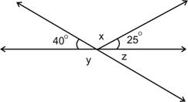

(a) 180° (b) 295° (c) 225° (d) none of these

- The value of 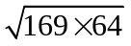 is
(a) 104 (b) 52 (c) 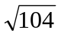 (d) none of these

- The value of x in 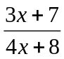 =  is
(a) 1 (b) 2 (c) 3 (d) none of these
- By selling an article for 1260, a man makes a profit of 5%. The cost price of the article is

(a) 1000 (b) 1100 (c) 1200 (d) none of these

- The mean value of 45, 34, 36, 42, x, 41 is 40. The value of x is

(a) 40 (b) 42 (c) 38 (d) none of these

